Dear Councillor
Following my earlier email, as you know, the motion to ban trail hunting on North Yorkshire Council-owned land has been sent to committee for discussion before a vote is taken later on in the year.
As a responsible, elected, councillor I am sure you will want as much information as possible in order to allow you to make an informed decision.
This is not a complicated issue but there is a lot of information so in the first place I would simply like to explain to you exactly what trail hunting is.
As you are probably aware, fox-hunting was banned in 2004. Trail hunting was set up at that time by the hunts to allow them to continue. Since then most people have assumed that because fox-hunting is banned, it doesn’t happen. They are mistaken – ‘trail’ hunting is the device that allows them to continue hunting as if there were no ban in place.
As time has passed the true position has become ever more clear – there are hours of footage on the internet showing foxes being hunted (along with the violence, aggression and intimidation from hunt supporters against those who oppose their illegal activity). More recently there has been ever-increasing amounts of footage on mainstream media being beamed directly into people’s homes. I am sure you have also heard of the infamous webinars during the Covid lockdown – these were run by the Master of Foxhounds Association and gave advice to hunts on how to avoid being caught illegally hunting. In their own words they called trail hunting a ‘smokescreen.’ The damage to the hunts was such that the MFHA rebranded and is now called British Hound Sports Association. It has now reached the point where the police have realised the truth of what is happening and Ch Supt Matt Longman, the National Police Chiefs’ Council lead on foxhunting, recently said that law on the crime is not working because it permits trail hunts that have become a “smokescreen” for the continued illegal persecution of animals. Indeed some police forces treat hunts as Organised Criminal Gangs and this is borne out by a recent rise in prosecutions.
If the hunts had been serious about hunting within the law they would have simply moved to drag hunting (following an artificial scent) or clean boot hunting (following a human runner). Trail hunting must not be confused with these legal activities and it is worth offering a comparison.
Two very useful references are
- ‘Trail of Lies. Report on the role of trail hunting in preventing successful prosecutions against illegal hunters in the UK.’ This is an IFAW report by Jordi Casamitjan, one of their investigators.
- ‘Uncovering the Trail of Lies’. Whereas the above is a full report, this is a summary report.
Some key points to come out of these reports are
- Comparisons with drag hunting and clean-boot hunting
- How the hunts use trail hunting to mask their illegal activity
- That the IFAW found that credible trails were laid in a mere 1% of cases.
Here is a table from the summary report that shows the many differences between trail hunting and drag and clean boot hunting
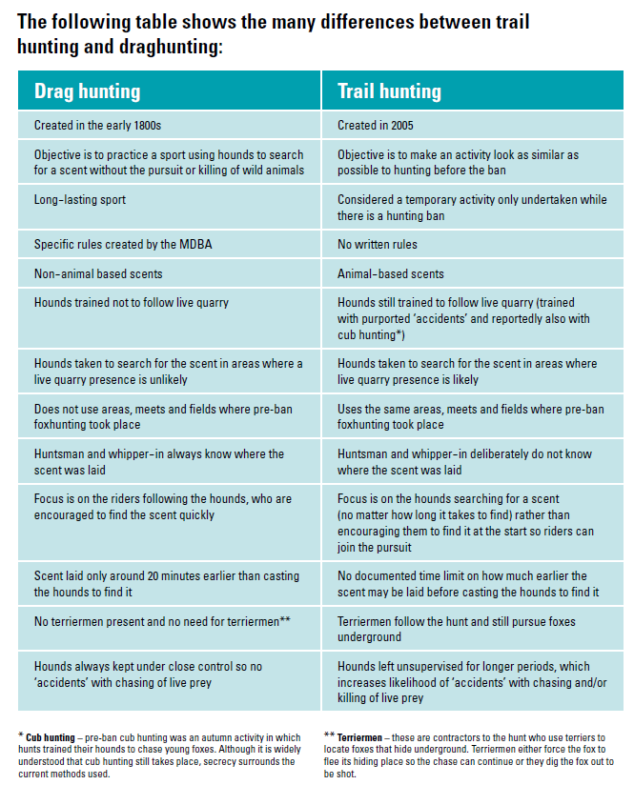
The report demonstrates the hunts use four main methods to create ‘false alibi’
- They lay no trail – they simply trust that people and authorities believe they do because they say they do, and they use instances like the traditional Boxing Day meet to reinforce this image
- Creating false evidence – they pretend to lay a trail, eg if they are being watched they might have someone with a rag ride on a quad bike.
- Faking it – similar to method three but over a longer period of time and more detailed
- Causing ‘accidents’ – they operate in areas they used to hunt in and where they know foxes to be. Even when they use ‘bagged foxes, they still claim the kill to be ‘accidental.’
I fully recommend you have a look at the summary report at least
One has to ask, if the hunts really are hunting within the law
- Why do they need to take terriermen with them?
- Why do they still train their hounds to kill through the evil practice of ‘cubbing’ (euphemistically called ‘autumn hunting)
- Why do they still maintain artificial earths to ensure there is a supply of foxes?
- Why do they use bagged foxes?
- Why do they deliberately cast the hounds into areas where they know foxes to be?
- Why do they use terriermen to flush foxes in advance of the hunt?
I will leave you with this quote by Clifford Pellow, a former huntsman who came to realise the horror of what he was doing
<<I've held a fox many times by the scruff and brush and felt how petrified they get; their hearts banging away like hell; farting and excreting and peeing every time the hounds speak. And I'm the person giving him three seconds to live. I am responsible for it. Absolutely ghastly.">>
Make no mistake – a vote against this motion will be a vote for illegal activity and animal abuse and cruelty.
Yours sincerely

