Event Management Plan - The Boxing Day Parade
Battle High Street & Abbey Green
Monday 26 December 2022 at 11am
The East Sussex and Romney Marsh hounds meet each year in Battle. The Boxing Day Parade, parades down the high street then will wait on Abbey Green for approximately 30 minutes before moving off. The parade is restricted to members and subscribers of the hunt.
Location
Battle High Street and horses and hounds gathered on the Abbey Green area marked in red here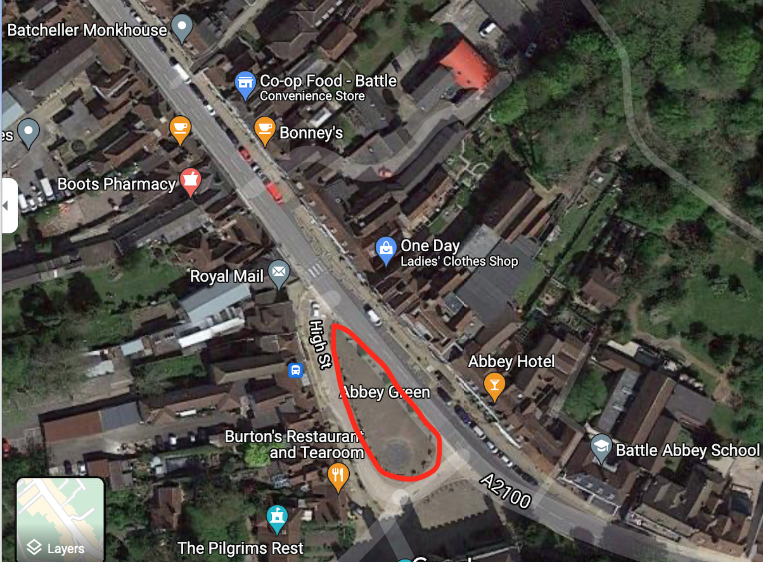
Entrance and Exit Points
The Boxing Day Parade shall come along The High Street from the Police Station end, and enter Abbey Green where sheep hurdles will be erected to stand hounds in an enclosed area.
Attendance
Attendance of the parade is restricted to members and subscribers of the hunt; approximately 300+ members of public and supporters also attend.
Audience Profile
The parade is restricted to member and subscribers of the hunt. The general public will observe the hunt from public places.
The Event Organisers
The event is organised by Diana Grissell, Senior Master of East Sussex and Romney Marsh Hunt
Tree of Responsibility
Diana Grissell – Parade Organiser
Hannah Taylor – Lead Marshall
Lena Pearson Wood– Lead First Aider
Rob Williams - Huntsman
Key Contacts
Overall responsibility for the parade. Diana Grissell M.F.H XXXXXXXXXX
Responsible for marshals on the day of the parade: Hannah Taylorl – XXXXXXXXXXX
Responsible for First Aid for members of the parade.Lena Pearson Wood – XXXXXXXXXXX
Responsible for the welfare and management of hounds: Rob Williams M.F.H – XXXXXXXXX
Litter
Litter resulting from the parade is normally limited to horse manure which shall be collected and removed by our own volunteers.
Toilets
Battle has public conveniences and the pubs also all have toilet facilities
Marshals
The Boxing Day Parade marshals will be supplied by the East Sussex and Romney Marsh and shall be responsible for ensuring safe and steady traffic flow.
Communication - Telephones
The Event Organiser and the Lead Marshal shall be in possession of mobile telephones in order to communicate with emergency services should the need arise. Mobile telephone signal has been checked and is available in Battle on the Abbey Green.

Media Enquiries
Media enquiries will be handled by the Event Organiser, Mrs Diana Grissell
Medical & First Aid
Lena Pearson Wood, a member of the East Sussex and Romney Marsh hunt will be on hand to provide first aid and medical assistance should a member of the Boxing Day Parade require first aid attention. She will be assisted by a second first aider, Hannah Taylor M.F.H. Any serious first aid or medical incident shall be reported to the emergency services immediately.
Fire Risk Assesement
N/A There are no identifiable risks of fire arising from the Boxing Day Parade and therefore the provision of fire extinguishers is deemed unnecessary.
Police
The Police will been informed of the Boxing Day Parade.. Any incidents on the day shall be reported to the Rural Crime Officer as advised by the British Hounds Association.
Incident Reporting
Any incidents will be recorded and reported by the Event Organiser, Diana Grissell, in accordance with the RIDDOR regulations.
Insurance
The East Sussex and Romney Marsh hunt holds Public Liability Insurance.
Extreme Weather
In the event of extreme adverse weather conditions which would render the Boxing Day Parade, as planned, unsafe, the Boxing Day Parade shall be conducted on foot rather than on horseback​.
Emergency Vehicle Access
Should emergency vehicles be required, they will be able to access the High Street, the marshals will facilitate such by moving the parade of horses and hounds.

RISK LOGS
ITEM | RISK | LEVEL | MITIGATION
Property
Cars lorries etc | Physical damage by horse | low | Marshals to co-ordinate event and ensure horses are in a specific safe area, Field Master to ensure all horses and riders are under control and safe before the event and send home any that are not
 | collision, kicking
Peoples property | Physical damage by | low | Huntsman to have hounds under close control, supported by whipper in. Hounds to be held up behind barriers
 | hounds
People
Members of the public | Injury by a horse | low | All horses to have been checked to be safe and under control. Horses will be held together and separate as far as possible from the public
 | Injury by a hound | low | Huntsmen to ensure good behaviour of hounds, hounds behind barriers
 | Disruption by protesters | medium | If this becomes a problem police presence to control. In previous years it has not been and protestors in very small numbers have peacefully stood.
 | Public anger of disruption | low | Marshalls in place to warn of traffic disruption, co-ordinated with police
Bio-contamination
Danger to the public | Excrement from hounds | low | Hounds and horses will have covered some distance through fields on the way, and so had a chance to empty. In event of any excrement Marshals team will clear up
 | and horses

